Ethnobotanical Study in Chinthamani Taluku

Srushtivijayakumar1, Harshavardhan M1, Dhatchnamoorthy2, Noorunnisa Begum2, Jyothi Uppar3, S Jyothsna B3

*1Student, Nrupathunga university- department of Botany and PG studies, City of Bengaluru, Karnataka, India*

*2Professor, The University of Trans- Disciplinary Health Sciences and Technology- City of Bengaluru, Karnataka, India* *3Professor, Nrupathunga university- department of Botany and PG studies, City of Bengaluru, Karnataka, India*

*Corresponding Author: drushika2000@gmail.com*

Abstract— **Ethnobotanical study on traditional medicinal plant was conducted between April and May 2024, in Chintamani taluk of Chikkaballapura district, Karnataka, India and documented different types of medicinal plants used by traditional healers. The study was focused on identifying medicinal plants, disease treated, part of the plant used, methods of preparation and more. The data was collected with structured questionaries by selecting two healers, with their complete agreement for sharing the information. The main objective of study constitutes to learn the indigenous knowledge from elderly and conserve the same through documenting them. A total of 36 medicinal plants were collected, the paper enumerates these medicinal plant species belonging to 34 genera and 25 families.**

*Index Terms—*Ethnobotanical, Medicinal, Plants, Traditional, Healers, Chinthamani taluk, Chikkaballapura district.

# Introduction

Ethnobotany is the study of interrelations between humans and plants, including plants used as food, medicine and for other economic applications (Amare Bitew Mekonnen, et al.,2022). The plant-based knowledge has been transferred from one generation to the next through herbalists, knowledgeable elders, and ordinary people. Traditional healers are the primary players in the curative aspect of traditional medicine practice. Gonfa et al., (2020).

The main objective of our study constitutes to learn the indigenous knowledge from elderly and conserve the same through documenting them.

The study was conducted in Karnataka state, in the district Chikkaballapura. This area is occupied mostly by scrub jungles and the people over this place are urbanized and are not leaving together as a community or group, even though there are few

Manuscript revised August 05, 2024; accepted August 06, 2024. Date of publication August 08, 2024.

This paper available online at [www.ijprse.com](http://www.ijprse.com)

ISSN (Online): 2582-7898; SJIF: 5.59

people with indigenous knowledge about plant and its medicinal properties, this aspect bought us to explore such informants around the study area, on the guidelines of local people.

# Materials and Methodology

## Study area:

The study was conducted in the region of Karnataka state in

the district Chikkaballapura, Chikkaballapura is a newly formed district which was carved out of the existing Kolar district. The study was chiefly done in Chintamani Taluk, which is a town in the same district, it is located at a distance of 75 km Northeast of Bengaluru and 40 km East of Chikkaballapura, it is well known as “business town”, the name Chintamani is supposed to have been given by a Maratha Warrior who had camped in the region. The town may have been named after a local king “Chintamani Rao”. The economy is agriculture based. Chintamani is famous for its succulent Tomatoes, Groundnuts, Mangoes, Silk production and Bananas. Tomato market is one of the biggest in Karnataka. Current estimated population of Chintamani taluk in 2024 is approximately 106,000.

## Rainfall:

Kolar and Chikkaballapura are located in the Semi-arid climate zone, with average rainfall of 690±201 mm.

## Temperature:

Temperature between 14.40C January to 35.70 C April.

### Selection of study sites

In the Chikkaballapura district, Chinthamani taluk was selected based on vegetation, distribution, availability of traditional healers and recommendation from local people for ethnobotanical data collection. There were no specific tribes present over here, since people over there are urbanized but we found that in J.J Colony, people follow the traditional method to use plants for medicinal purposes that are found in their locality.

A total of 2 informants between ages 44 to 70 were selected based on the recommendation from local people in that area, belong to Madiga community, the details of the informants is been given below in the table.

Table.1. List of informants used by traditional healers of Chinthamani taluk.

|  |  |  |  |  |  |
| --- | --- | --- | --- | --- | --- |
| **Name of the Local vaithiyar** | **Locality** | **Age** | **Occupation** | **Human/Animal aliments** | **NO.of plants used** |
| Venkatamma | J.J Colony | 68 | Vegetable vendor | Human | 08 |
| Rajamma | J.J Colony | 44 | Vegetable vendor | Human | 28 |

### Data collection

Ethnobotanical data were collected from April to May 2024. The data collected from the informants was clearly out of their concern, we first explained them in detail about the project and the information present in the consent form and made sure that they were free to share their knowledge without any hesitation, later we took the signature of agreement from the informant in the consent form declaring the same.

These data were collected using structured questionaries, field observation and group discussion. Data is an indigenous knowledge about plants and their medicinal properties and traditional usage of the same. The information such as the plants local name, its medicinal property, curative effect on particular common human health diseases, preparation of medicine and their key ingredients, dosage of medication, periodical diet need to be followed when under treatment, ways of application and time of taking the treatment were collected.

The medicinal plants were collected in the field with the help of the informant and the date, collection number, latitude & longitude, local name was noted on the spot but the plants which were not identified in the field were pressed and dried for voucher specimen to be identified in FRLH herbarium in TDU, Bengaluru.

### Identification of plant

The plant specimen was collected and identified at FRLH by referring standard local flora (Gamble, 1957; Gopalakrishna Bhat, 2003; Saldanha, 1984; Saldanha, 1996; POWO, 2024).

### Data analysis

The data were analysed and summarized by descriptive statistical analysis by using Microsoft excel spreadsheet software. The data was analysed by using formula such as =Count IF (F6: F64, “Tree”) to calculate the frequency of families, genus collected, habit, plant part used, route of administration and application of prepared remedies.

# Results and Discussion

A total of 36 medicinal plant species belonging to 34 genera and 25 families were identified and documented from the study area.

Euphorbiaceae and Solanaceae constituted highest number of medicinal species, and all others had least count of species. The families had shown the presence of utilization of various medicinal plants in the study area.

## Habit of medicinal plants:

Medicinal plants collected in respective study area have different growth forms. From the collected plant species, herbs (16) were the leading growth habit, followed by shrub (09), trees (06), Climber (05) This shows that most commonly used medicinal plant habit in the study area were Herbs followed by Shrubs, Trees and Climbers. This confirmed that Herbs and Shrubs were abundant growth forms in the study area.

## Plant parts used:

According to the informant they use different parts of plant for medicinal purposes, most of the used plant part are leaves (19) and followed by root (3), latex (2), seeds (2), flower (2), and few other parts like fruit gal and chipped wood in a least count. This result shows that leaf is the most commonly used plant part in the preparation of remedies.

## State of preparation from plant materials:

According to the study it was encountered that, the local people prepared the medicines from fresh, dry and both fresh and dry plant materials, it showed that the medicines are prepared dominantly in their fresh form, they believe that freshly prepared remedies are more effective and give faster curative relief than in the dry form.

## Route of administration:

The medicinal remedies are given in several routes such as oral, dermal, nasal, ocular, ear, fumigate. In the study it was learned that the most common route of administration is oral (17) and is followed by dermal, (15) others like nasal, fumigate and ear were the least practiced route of administration. Informant explains that these routes like oral and dermal is one of the easiest routes and also effective, they also add that patient would not be feeling anxiety or uncomfortable with these routes when compared to other. Hence this concludes that oral route of administration is the most common and dominant amongst rest.

## Medicinal plants used to treat human diseases:

Medicinal plants that were collected in the study area that used for human health problems were a total of 36 medicinal species belonging to 34 genera and 25 families were identified and documented from the study area which 25 different diseases can be cured or relieved. The family Euphorbiaceae and Solanaceae is the dominant family and followed by Malvaceae, Poaceae, Minispermaceae, Lamiaceae, Apocyanaceae, Convovulaceae were found with 2 species each and Fagaceae, Rutaceae, Nyctangiaceae, Plantaginaceae and others were least found with one species, however dominance of family Euphorbiaceae and Solanaceae for the treatment of human diseases was reported.

## Various plant parts used for human diseases:

Each human disease is cured in a unique manner and these appreciations belong to the peculiar nature of each part of the plant. According to traditional healers every plant is hidden with its own medicinal property, which is yet to be explored, this explains that every part of the plant is distinct with its own medicinal values, likewise in the collection of 36 different plants we encountered that some diseases are cured by using particular part of the plant, like the flowers of hibiscus is to be eaten raw to relieve from menstrual problems, roots of Cynodon dactylon is used to relieve poison from centipede bites, similarly roots of Calotropis gigantea is used to relieve poison from snake bite, the seeds of Centratherum anthelminticum are used to treat diabetes and more.

## Major human diseases and plant species used to treat them:

In the study area, totally 25 human diseases which were reported to be treated by 36 different plants. Some of the major diseases are cough, asthma, headache, knee cramps etc they are also few diseases caused by accidents such as burnt wounds, snake bite and centipede bite. All the diseases have their own remedial preparation, one plant species can cure more than one disease.

## Transfer of medicinal plants knowledge:

The informants do not transfer their knowledge very easily to the other person or their younger ones because they feel that the power of medicine would vanish in the plant if the name of the plant is taken or said to someone, the reason behind it is person with the knowledge might misuse it and brings threat to the society. Only if a person can gain his/her belief they decide to transfer their knowledge. As most informants reported that transferring their indigenous knowledge to younger generation is decreasing day to day due to the refusal of young to learn the same, this might be due to urbanization, modern medications, lack of belief and lack of interest. It is hard to learn this indigenous knowledge from the people because it’s oral based knowledge and very low percentage of it is recorded. Due to all these problems the knowledge gets vanished with the death of elderly and is gone forever.

# Conclusion

Based on the result, it can be concluded that the study area is rich in diversity of medicinal plant species and largely from wild habitat and few from home gardens. Totally 25 different human diseases and their remedies are recorded. This indigenous knowledge is owned by people of older age. It is also concluded that herb and shrub are the most common habit of plants in the study area. Leaves are found to be most used plant part which is followed by whole plant and seeds for preparation of medicine. The state of medicine is majorly in fresh form than in its dry form due to the effectiveness and availability. The most common route of administration is oral and is followed by dermal since it is the easy and effective route to administrate. The transfer of indigenous knowledge is decreasing day by day due to refusal of young to gain the knowledge, urbanization, lack of interest it is one of the major reasons for disappearance of indigenous knowledge.

Table.2.

list of plant species used by traditional healers of Chintamani taluk

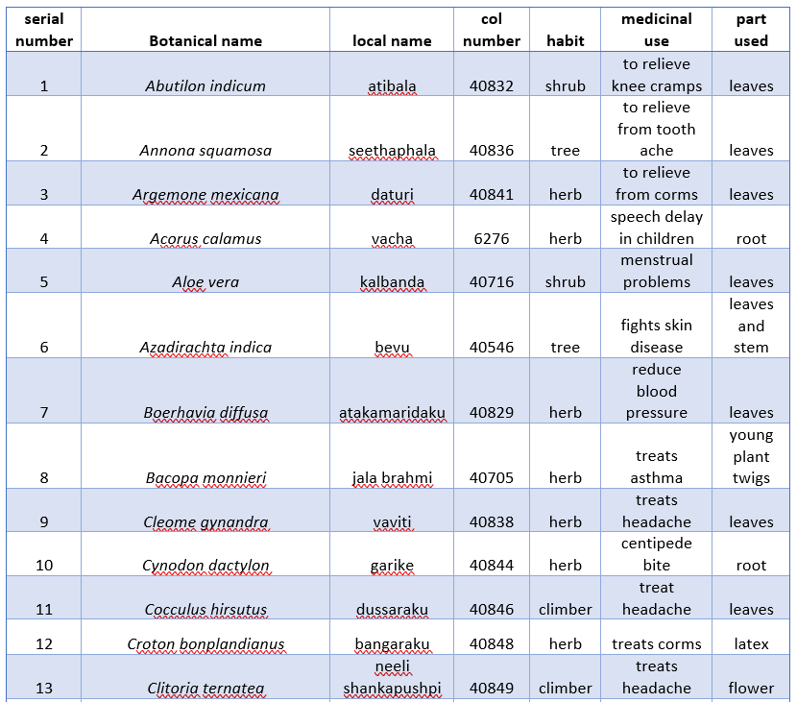

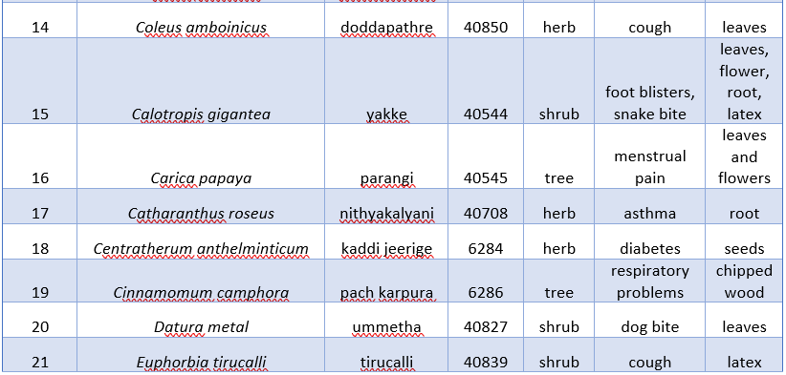

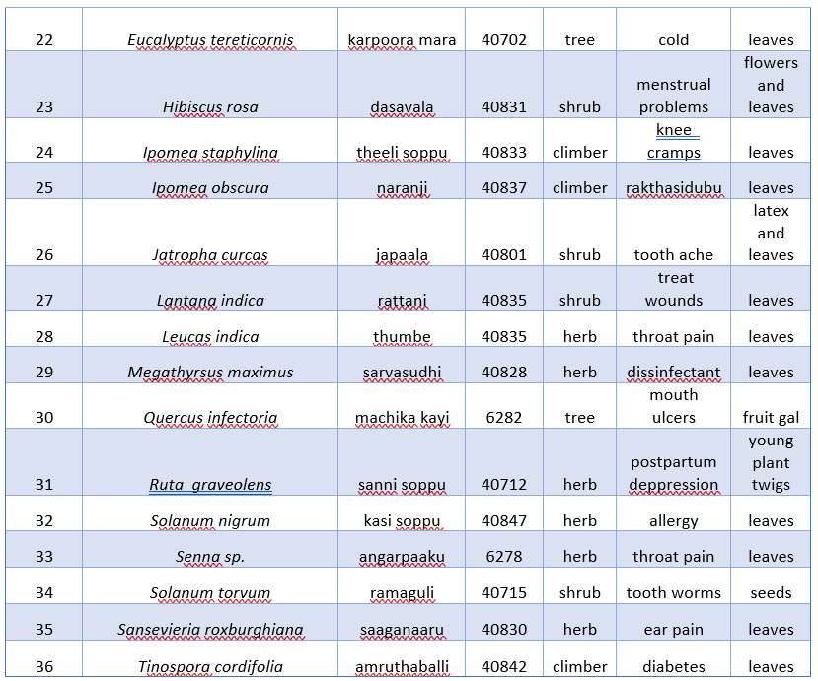

References

1. Amare Bitew Mekonnen, et al., 2022. Ethnobotanical Study of Traditional Medicinal Plants Used to Treat Human and Animal Diseases in Sedie Muja District, South Gondar, Ethiopia
2. Bhat, Gopalakrishna K., 2003, Flora of Udupi. Indian Naturalist, Udupi.
3. Cogent Food & Agriculture 6(1).
4. Ethiopia.
5. Gamble, J. S. 1957, Flora of the Presidency of Madras. Vol I, Part IV. Botanical Survey of India, Government of India, Calcutta
6. Gamble, J. S. 1957, Flora of the Presidency of Madras. Vol II, Part IV, Botanical Survey of India, Government of India, Calcutta.
7. Gamble, J. S. 1957, Flora of the Presidency of Madras. Vol III, Part IV. Botanical Survey of India, Government of India, Calcutta
8. Gonfa, N., Tulu, D., Hundera, K., Raga, D., & Yildiz, F. (2020). Ethnobotanical study of medicinal plants, its utilization, and conservation by indigenous people of Gera district,
9. Rakesh Samar, et al., 2013. Ethnobotanical Study of Traditional Medicinal Plants Used by Tribe of Guna District, Madhya Pradesh, India.
10. Rao, R.R. & Razi, B.A. 1981. A Synoptic Flora of Mysore District, published by Today & Tomorrow’s Printers and Publishers.
11. Saldanha, C.J. 1984. Flora of Karnataka, Vol I. Magnoliaceae to Fabaceae. Oxford & IBH Publishing Co. PVT. LTD, New Delhi.
12. Saldanha, C.J. 1996. Flora of Karnataka, Vol II. Podostemaceae to Apiaceae. Oxford & IBH Publishing Co. PVT. LTD, New Delhi.
13. Seetharam, Y.N., Kotresha, K., Uplaonkar, S.B. 2000. Flora of Gulbarga district, Gulbarga University, Karnataka, India.
14. Sharma, B.D., Singh, N.P., Raghavan, R.S., & Miss. U. R. Deshpande. 1984. Flora of Karnataka analysis. Botanical Survey of India.
15. South East Ethiopia", Evidence-Based Complementary and Alternative Medicine, vol. 2018, Article ID 8602945, 16 pages, 2018.
16. POWO 2024. "Plants of the World Online. Facilitated by the Royal Botanic Gardens, Kew. Published on the Internet;
17. Tilahun Tolossa Jima, Moa Megersa, "Ethnobotanical Study of Medicinal Plants Used to Treat Human Diseases in Berbere District, Bale Zone of Oromia Regional State.